***NAME : Himanshu Dixit***

***ENROLL NO. : B64178***

***BATCH : B10***

***SOFTWARE DEVELOPMENT FUNDAMENTAL LAB-I(15B17CI171)* *Assignment Sheet (WEEK-3 PHASE-2)***

***Lab B***

1. WAP in C which prints the greater of two numbers inputted by the user.

**Solution:**

#include<stdio.h>

int main()

{

int a, b;

printf("print two number=");

scanf("%d %d",&a,&b);

if(a < b)

{

printf("greater number is %d",b);

}

else if(a > b)

{

printf("greater number is %d",a);

}

else

{

printf("both are equal");

}

return 0;

}

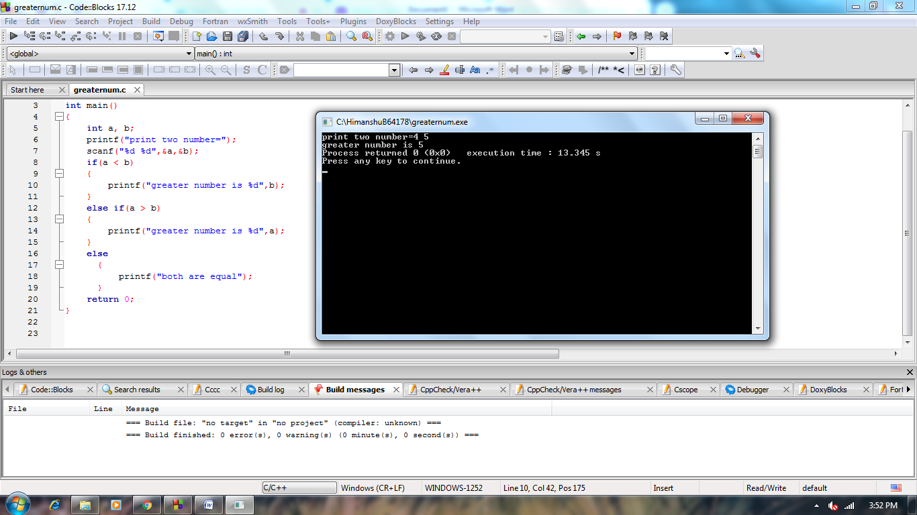

1. WAP in C to identify whether the input number is positive or negative.

**Solution:**

#include<stdio.h>

void main()

{

int num;

printf("enter number= ");

scanf("%d" ,&num);

if(num>0)

{

printf("number is positive");

}

else if(num<0)

{

printf("number is negative");

}

else

{

printf("neither positive nor negative");

}

}

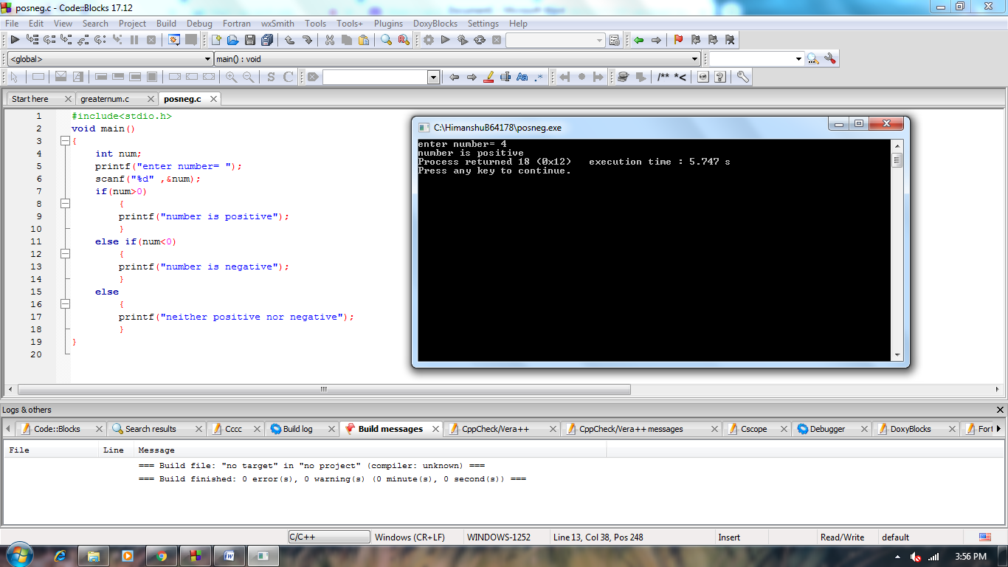

1. WAP in C to identify whether the input number if even or odd.

**Solution:**

#include<stdio.h>

int main()

{

int n;

printf("inter the number:");

scanf("%d",&n);

if(n%2==0)

{

printf("even number");

}

else

{

printf("odd number");

}

return 0;

}

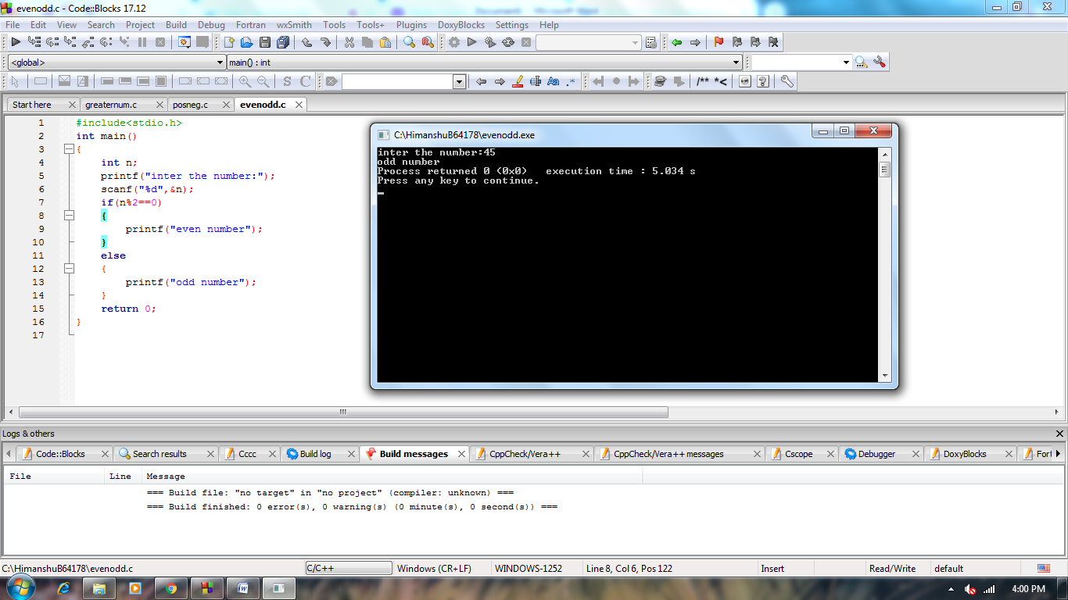

**4.**   WAP in C to check whether the input character is a Vowel or Consonant.

**Solution:**

#include<stdio.h>

int main()

{

char c;

printf("enter alphabet :");

scanf("%c",&c);

if(c=='A'||c=='E'||c=='I'||c=='O'||c=='U'||c=='a'||c=='e'||c=='i'||c=='o'||c=='u')

{

printf("vowel");

}

else

{

printf("cansonant");

}

return 0;

}

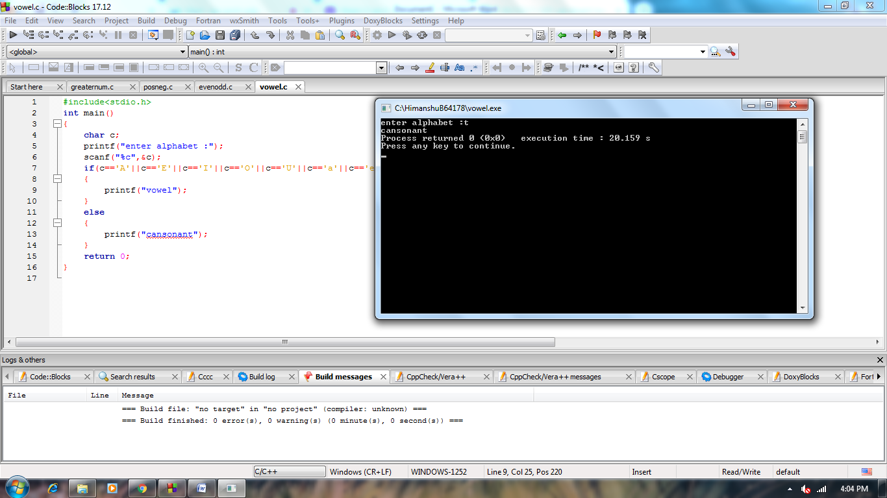

**5.**   Write a C program to check whether a triangle is Equilateral, Isosceles or Scalene.

Test Data :

50 50 60

*Expected Output* :

This is an isosceles triangle.

**Solution:**

#include<stdio.h>

void main()

{

int a,b,c;

printf("enter the 3 sides of triangle :");

scanf("%d%d%d",&a,&b,&c);

if(a==b&&b==c&&a==c)

printf("equilateral triangle");

else if(a==b||b==c||a==c)

printf("isosceles triangle");

else

printf("scalene triangle");

}

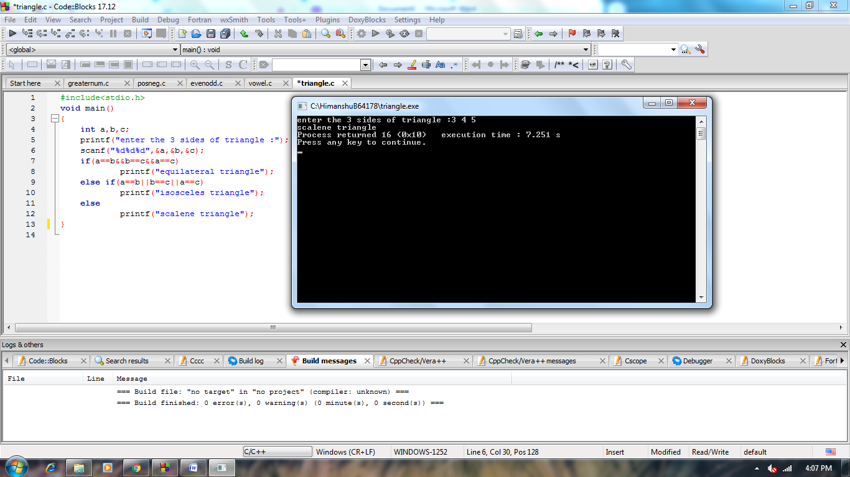

**6.**   Write a program to find out if the year entered is a leap year or not.

**Solution:**

#include<stdio.h>

void main()

{

int year;

printf("Enter a year: ");

scanf("%d",&year);

if((year%4==0)&&((year%400==0)||(year%100!=0)))

{

printf("%d is a leap year",year);

}

else

{

printf("%d is not a leap year",year);

}

}

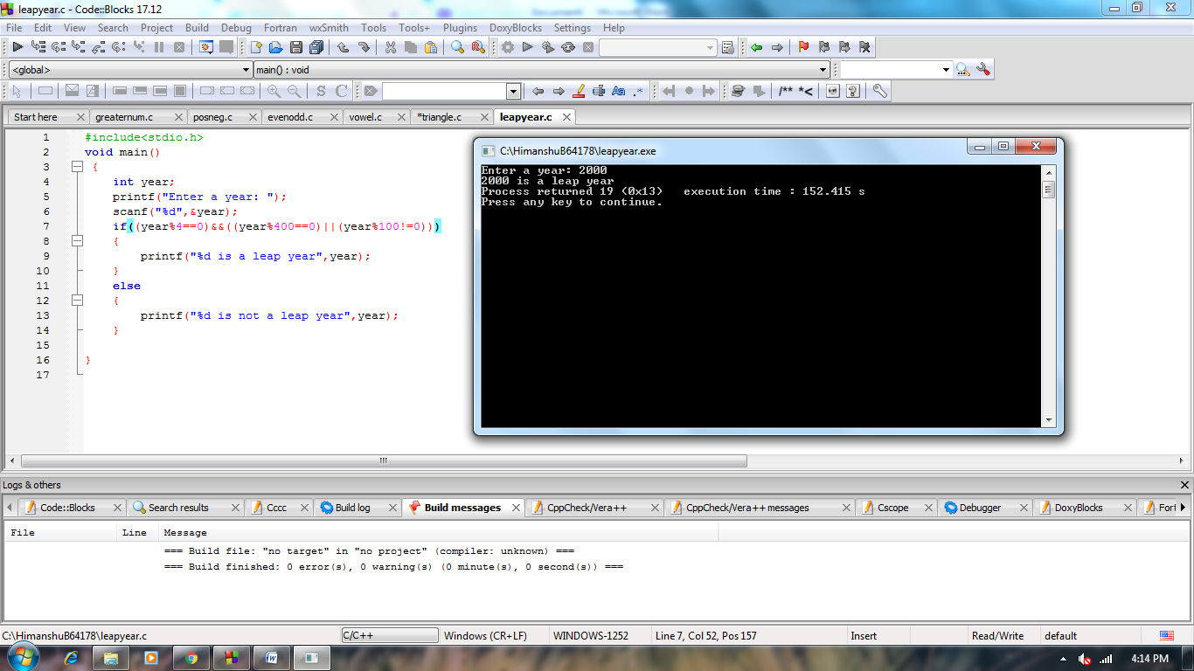

**7.**   Write a program to find the largest number among the given three numbers

**Solution:**

#include<stdio.h>

void main()

{

int a,b,c;

printf("enter 3 number :");

scanf("%d%d%d",&a,&b,&c);

if(a>b&&a>c)

printf("%d is greater",a);

else if(b>a&&b>c)

printf("%d is greater",b);

else

printf("%d is greater",c);

}

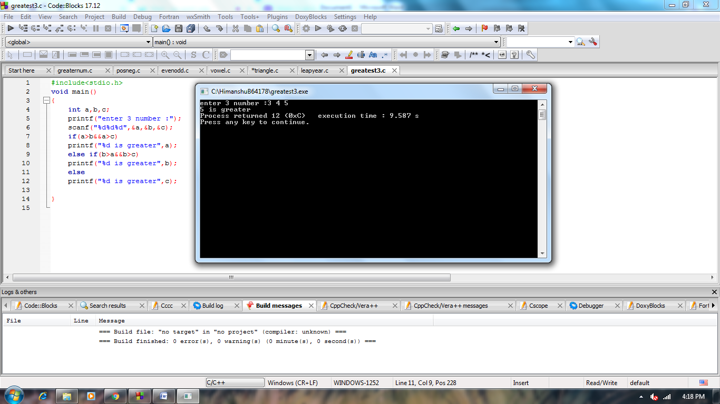

**8.**   Write a C program to input electricity unit charge and calculate the total electricity bill according to the

given condition:

For first 50 units Rs. 0.50/unit

For next 100 units Rs. 0.75/unit

For next 100 units Rs. 1.20/unit

For unit above 250 Rs. 1.50/unit

An additional surcharge of 20% is added to the bill and the minimum bill amount should be Rs. 100.

**Solution:**

#include<stdio.h>

void main()

{

int unit;

float ele_bill,tot,surcharge;

printf("enter electricity unit :");

scanf("%d",&unit);

if(unit<=50)

ele_bill=0.50*unit;

else if(unit<=150)

ele_bill=50*0.50+(unit-50)*0.75;

else if(unit<=250)

ele_bill=50*0.50+100*0.75+(unit-150)*1.20;

else

ele_bill=50*0.50+100*0.75+100*1.20+(unit-250)*1.50;

if(ele_bill>=100)

surcharge=0.2*ele_bill;

else

surcharge=0;

tot= ele_bill+surcharge;

printf("%f is the total charges",tot);

}

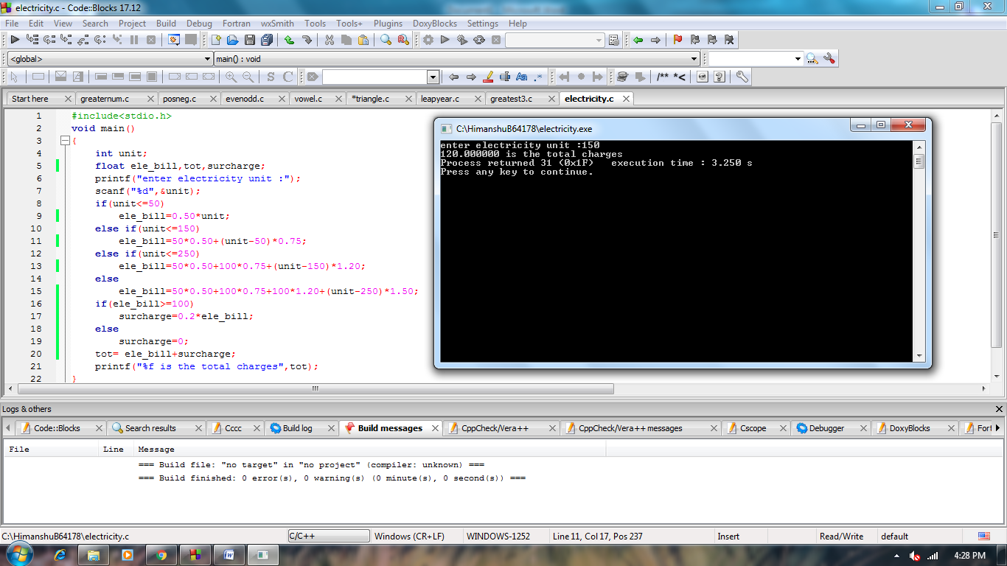

**9.**   Write a C program that will take the amount from user and print minimum number of notes (Rs. 500, 100,

50, 20, 10, 5, 2, 1) required for the amount. For example :

Input amount: 576

Output

Total number of notes:

500: 1 , 100: 0 , 50: 1, 20: 1, 10: 0, 5: 1, 2: 0, 1: 1

**Solution:**

#include<stdio.h>

void main()

{

int amount,a,b,c,d,e,f,g,h,i,j,k,l,m,n,o;

printf("enter amount :");

scanf("%d",&amount);

a=amount/500;

b=amount%500;

c=b/100;

d=b%100;

e=d/50;

f=d%50;

g=f/20;

h=f%20;

i=h/10;

j=h%10;

k=j/5;

l=j%5;

m=l/2;

n=l%2;

o=n/1;

printf("number of 500 rupees notes : %d\n",a);

printf("number of 100 rupees notes : %d\n",c);

printf("number of 50 rupees notes : %d\n",e);

printf("number of 20 rupees notes : %d\n",g);

printf("number of 10 rupees notes : %d\n",i);

printf("number of 5 rupees notes : %d\n",k);

printf("number of 2 rupees notes : %d\n",m);

printf("number of 1 rupees notes : %d\n",o);

}

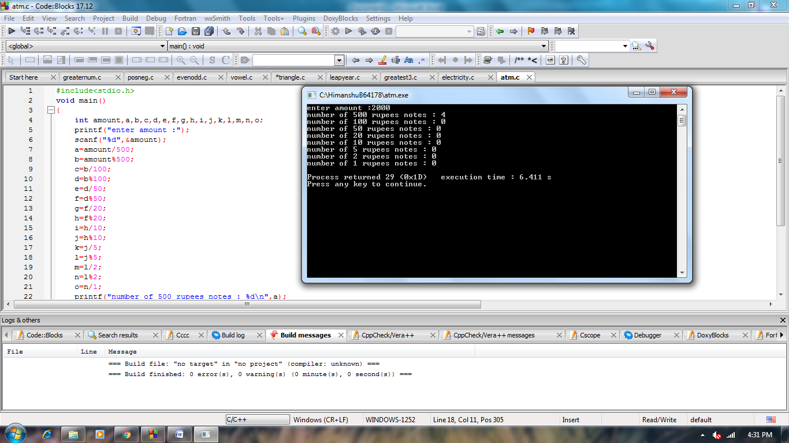

10. The gross salary of an employee in a firm is calculated on the basis of the following

Formula: Gross = Basic + DA+HRA.

Write a C program to input basic salary of an employee and calculate gross salary according to given

conditions.  
 Basic Salary <= 10000 : HRA = 20%, DA = 80%

Basic Salary is between 10001 to 20000 : HRA = 25%, DA = 90% Basic Salary >= 20001 :

HRA = 30%, DA = 95%

**Solution:**

#include<stdio.h>

void main()

{

int basic;

float gross,hra,da;

printf("enter basic salary :");

scanf("%d",&basic);

if(basic<=10000)

{

hra=0.2*basic;

da=0.8*basic;

}

else if(basic<=20000)

{

hra=0.25*basic;

da=0.9*basic;

}

else

{

hra=0.3*basic;

da=0.95*basic;

}

gross=basic+hra+da;

printf("%f is the total salary",gross);

}

